Cubbington Parish Council
Minutes of the Parish Council Meeting held at 7:00pm 26th March 2026
the meeting was held at the Village Hall

Present:
Councillor Ian Hodges (Chairman) Councillor Gary Willoughby
Councillor Paul Watkins (Vice Chairman) Councillor Esther McCarthy
Councillor Daniel Meggitt Councillor Pete Smith
Councillor David Saul Councillor Jane Coad
Councillor Martin Key

Warwick District Councillors: Councillor Phil Kohler, Councillor Alan Boad

Warwickshire County Council: Councillor Ben Edwards, Councillor Sarah Boad

Members of the public: 0

In Attendance: Jane Chatterton, Proper Officer Clerk & RFO

Councillor Hodges was in the Chair. The Chairman welcomed everyone to the meeting.

974. Apologies
Apologies for absence were received from WDC Councillors Pam Redford, Daniel Russell and Josh Payne.

975. Declarations of Interest:
Declarations of Interest were received from:
Councillor McCarthy - Pavilion Committee and Village Hall
Councillor Ian Hodges - Village Hall
Councillor Pete Smith - Pavilion Committee
Councillor Daniel Meggitt - Pavilion Committee

976. Minutes of the last meeting
The minutes of the Parish Council Meeting held on 26th February 2026 were received and discussed.

RESOLVED THAT the minutes of the Parish Council Meeting held on 26th February 2026 were approved.

977. Matters arising
There were no matters arising not listed on the agenda.

978. Public Participation
No members of public present.

979. Councillor’s Reports
WCC Update – Councillor Ben Edwards
Potholes
Potholes in the parish had been raised on the system. These were due to be fixed today but had been delayed due to emergency jobs.

Posts/bollards and parking on New Street
The Enforcement Team had been requested to be involved.

Minor Works Team had been contacted to decide on how and where any posts could be installed. Councillor Edwards had requested a meeting to resolve the problems with the Engineering Team.

Crossings
Surveys had conducted to gather the relevant data to count vehicles and pedestrians. The results would be collated and we would see where we go from there. Continue to put pressure on the Head of the Council.

980. Correspondence
Nothing further to report.

981. Chairman’s Report
Hobby centre
We have a new group that wants to operate at a different time to the existing times, this will be at the weekends to cover people who are unable to attend the normal times.

The centre is still attracting people who come to have a chat and a cuppa.

Village Hall
The Village Hall subsidence is now being assessed by the parties involved through the insurance company and we await their findings.

The new lighting to the car park has now been installed to the front carpark, which seems to have solved the problems that we were experiencing.

MUGA
Planning is now live for the MUGA and the Clerk is trying to obtain grants to fund this venture

Recreation Ground
The wildflower meadow has started to grow and the picket fence around it to deter dogs and walkers from the area has been ordered. This will be installed by the Hobby centre.

Pay Back Team
I had a meeting with the new payback team leaders and discussed the areas that are to be serviced by the group. A set of keys for the toilet and overhead barrier are being supplied.

982. Councillors’ Reports in brief
982.1 Pavilion Update
Councillor Meggitt updated that the new doors were in the workshop ready to be installed at the Pavilion. Work continued on looking at the possibility of making the doors electronic. Some maintenance work had been completed including plumbing jobs.

982.2 Community
Litter pick
The parish litter pick had taken place on Saturday down the Coventry Road. Cleared a lot of rubbish.

Potholes
The potholes on Church Lane had been filled.

Break-in
It was reported that there had been a break-in at Best One, the community had helped with the clear up.

Village Hall Panto
The panto was booked and would be advertised shortly.

Adult Panto
To be discussed further.

982.3 Youth Club
Councillor McCarthy reported that Youth Club continued to be enjoyed by the young members of the Parish. The number attending was good and manageable. Various activities were offered including kick boxing and cricket.

Thank you to the local shops and businesses who had provided donations.

983. Task Groups
It was noted that all Task Group leads had agreed that they would prepare reports ahead of the meeting but this was not being done.

983.1 Planning (Councillor Willoughby)
The two major planning issues for Cubbington remain
- Richborough Estates homes (Leicester Lane / Blackdown) as this were within the Parish boundary and
- indirectly the Kings Hill / Finham development, simply due to it's size and impact on transport / surrounding infrastructure.

Thanks to the hard work of Councillor Watkins, a Leaflet and online Survey to gather residents views on the SG06 Richborough Estates and SG05 Offchurch Lane proposals had been produced together with requests for quotations from planning consultants to provide an independent report on SG05 reviewing the Regulation 18 Preferred Option of the emerging South Warwickshire Local Plan.

Pavilion, Stonehouse Close, Cubbington, Leamington Spa, CV32 7LP
Installation of Multi-Use Games Area - W/25/1780 - in progress & submitted for planning permission - 22/12/2025

No other significant planning issues / concerns have currently been identified by or to the Parish Council.

983.2 Flooding
No issues reported.

983.3 Defibrillators
Weekly inspection of the 4 defibrillators in Cubbington Parish Council continues - no issues.

983.4 Park Inspections
Further damage to perimeter school fencing Austen Court but school had advised that they had grant from WCC for new fencing.

No new issues - all risks were being tolerated or actions are under review / in progress with the Clerk.

Copies of the inspection reports were available on request.

984. District and County Councillors’ Reports for information
WCC update - Councillor Sarah Boad
Buses
Proforma to be completed before the meeting, Councillors McCarthy and Coad had provided input.

It was noted that the morning buses don’t turn up. Councillor Boad to provide the feedback.

Rural East Police Meeting
The person who was stealing from Sainsburys had received a custodial sentence and the thefts had stopped. However, recently that had started again.

WDC Update – Councillor Kohler
Roxburgh Croft play area
A walk round would take place tomorrow with the Portfolio Holder to look at improvements.

South Warwickshire Local Plan
A briefing meeting was taking place this evening.

Proposed housing development
It was noted that the Parish Council needed to make a list of things if the housing development does receive approval in mitigation, including traffic lights instead of the mini roundabout on the Rugby Road. Measures should be included to prevent flooding prevention and improvements on the current situation.

985. Highways
Nothing further to report.

986. Police
986.1 Police Liaise meeting
It was reported that Councillors Hodges and Saul attended the Rural East meeting on Monday 23rd March 2026.

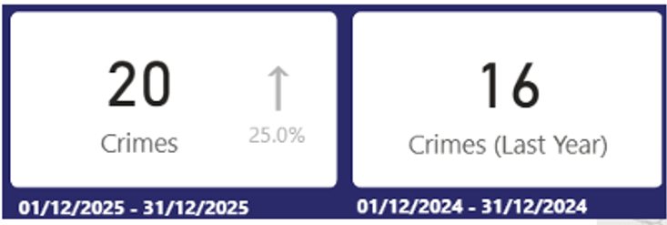

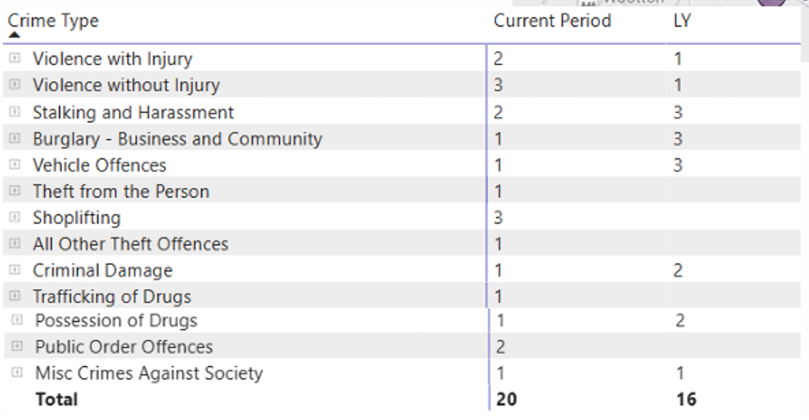

Thanks was given to PSCO Ed King for what he does for the SNT.

986.2 Break-in
It was reported that there was a break-in at the Post Office on Sunday evening. 4 offenders, looked at the door and jemmied the door off and smashed their way in. They had dismantled the cigarette counter and had taken money from the Post Office.

987. Finance
987.1 2025-26 – EXPENDITURE
DATE | REF | DETAILS | AMOUNT
28.01.26 | E185 | Metcalfe Inv 941115 | £69.60*
28.01.26 | E186 | Metcalfe Inv 945552 | £192.00*
28.01.26 | E187 | Metcalfe Inv 945560 | £18.48*
28.01.26 | E188 | Metcalfe Inv 945570 | £50.16*
28.01.26 | E189 | Metcalfe Inv 945704 | £479.57*
30.01.26 | E190 | Unity Service Charge | £6.00
30.01.26 | E191 | SSE DD01389030 | £71.45*
03.02.26 | E192 | Mr Willoughby Inv 00089 | £84.00
03.02.26 | E193 | Mr I Hodges Reimbursement for Ink | £71.51*
03.02.26 | E194 | Tom White Waste IAC203646 | £82.27*
03.02.26 | E195 | J Chatterton www.jrbenterprises.com dog poo bags | £145.56*
05.02.26 | E196 | J Chatterton Clerk Salary February | DPA
05.02.26 | E197 | HMRC Employer NI Employee Tax & NI | DPA
05.02.26 | E198 | WCC Clerk Pension Employer & Employee | DPA
13.02.26 | E199 | Mr Hodges reimbursement Tamara Glass Ltd HC | £222.84*
13.02.26 | E200 | Hobby Centre Website Renewal S Hodges | £187.06*
13.02.26 | E201 | J Chatterton Solar Technology Car park lights | £743.70*
13.02.26 | E202 | J Chatterton The Metal Store Car park lights posts | £247.50*
13.02.26 | E203 | J Chatterton First Fence Ltd Car park lights barriers | £340.68*
13.02.26 | E204 | J Chatterton Paperstone 982440 | £85.94*
16.02.26 | E205 | J Chatterton rectification for E204 £103.13 - £85.94 | £17.19
21.02.26 | E206 | J Chatterton First Fence Ltd Car park posts & bolts | £432.96*
21.02.26 | E207 | J Chatterton PC reimbursements February | £87.99*
23.02.26 | E208 | SSE Bus Shelter DD | £71.45*
28.02.27 | E208a | Unity Service Charge | £6.00
11.03.26 | E209 | J Chatterton Costco Membership Reimbursement | £78.00*
11.03.26 | E210 | WDC CCTV Annual Charge | £4,235.00
11.03.26 | E211 | WALC Invoice Training GW | £42.00*
11.03.26 | E212 | Mr Willoughby Inv 00090 | £112.00
11.03.26 | E213 | D Meggitt Pavilion repairs | £543.83*
11.03.26 | E214 | npower Christmas Lights | £64.08*
11.03.26 | E215 | Tom White invoice IAC209227 | £39.89*
11.03.26 | E216 | J Chatterton Clerk Salary March | DPA
11.03.26 | E217 | HMRC Employer NI Employee Tax & NI | DPA
11.03.26 | E218 | WCC Clerk Pension Employer & Employee | DPA
18.03.26 | E219 | J Chatterton First Fence car park lights | £288.29*
18.03.26 | E220 | J Chatterton First Fence car park lights | £129.34*
18.03.26 | E221 | J Chatterton PC reimbursements March | £87.99*
18.03.26 | E222 | ICO Membership | £47.00
18.03.26 | E223 | I Hodges Reimbursement HC and Rec Ground | £1,125.73*
*inc VAT

RESOLVED THAT
- the payments be approved.
- Clerk to terminate CCTV contract.

987.2 Bollards on New Street
Carry over to May’s meeting.

987.3 UVE Planning Support

RESOLVED THAT
- CPC engage UVE Planning Support to carry out work on the SG05.
- Option 2 at £2,600.
- Clerk to engage the UVE.
- Clerk to update Old Milverton and Blackdown.

987.4 Leaflet drop
It was decided not to continue with a leaflet drop.

988. Governance
The following policies were received and reviewed.

- Asset Register 2025-26
- CPC Internal Financial Control March 2026 (no updates)
- CPC Risk Assessment March 2026 (no updates)
- CPC Health & Safety Policy March 2026 (no updates)

RESOLVED THAT the above policies be reviewed.

ACTION: Chairman and Clerk to make arrangements to have the Pavilion and Village Hall revalued.

989. Planning Matters
Nothing further to report.

990. HS2 Update
Nothing further to report.

991. Councillor’s reports and items for future Agenda:
Nothing further to add.

992. Date of the Next Meeting
The date of the next meeting was confirmed as Thursday 28th May 2026 including the Annual Parish Council Meeting and Annual Parish Meeting.

Meeting closed at 8:20pm

