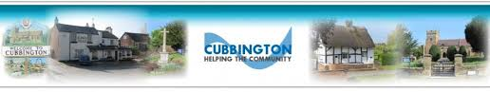
In partnership with


Guidance for Residents in Times of Flood
Dear Residents,
This leaflet and accompanying information has been jointly compiled with the collaboration of Warwickshire County Council Highways & Flood Management Team, Severn Trent Water. WDC and the Environment Agency.
Whilst Cubbington Parish Council have no direct responsibility for highways, drains, sewers or water courses following the flooding event earlier this year, the Council formed a Flood Prevention & Maintenance Working Group to liaise with the above.
The aim was to better understand the river, drainage and sewerage networks, establish what preventative measures and maintenance is currently in place and provide accurate contact points for both urgent and non urgent issues via websites and telephone (please see overleaf). This information will also be available on the Parish Council website.
In summary, as a result of these meetings several key actions have been undertaken....
- The Environment Agency have inspected the Pingle Brook and found no issues.
- Severn Trent Water have inspected with CCTV both the surface water and the foul sewerage network from Church Lane – New Street and found no issues.
- WCC Highways have increased drain inspections and jetting to the key streets.
- We established that the 2014 flood alleviation scheme is owned by Warwick District Council and will be maintained by them.
- Volunteer Community Flood Street Wardens for key streets have been identified.
- Raised the profile and priority of Cubbington with key agencies.
The Group will now meet as required and a standing agenda item will be on every Parish council meeting.
Cubbington is not seen as a high-risk flood area due to the low numbers of problems reported and logged on the agencies databases. It is important that any issues are raised with the relevant agencies and that you receive an incident number as a formal record.
The information overleaf is intended to support you in order that Cubbington gets the level of service and investment it rightly deserves in the future.

On behalf of Cubbington Parish Council

