[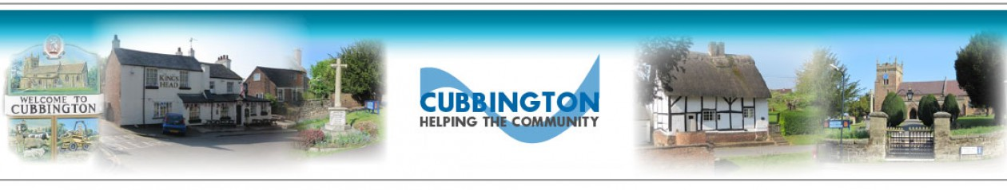](https://cubbingtonparishcouncil.wordpress.com/)

**CUBBINGTON PARISH COUNCIL**

**BUSINESS PLAN**

**2024-25**

**Approved: Final Approved 23rd May 2024**

**Review: end September 2024, December 2024, March 2025**

**Updated:**

**WHAT IS A PARISH COUNCIL BUSINESS PLAN?**

The Business Plan is the statement of the Parish Council’s *vision* for the parish, its purpose, values, objectives and its key priorities. The aim of the Business Plan is to give Cubbington’s residents a clear understanding of what the Parish Council does and what it is trying to achieve. It details what the Parish Council intends to focus on over the next four years. The Business Plan is a *“live”* document that we will review annually. The Parish Council will use it to drive the budgeting process, plan and communicate activities for the coming year and enable the Parish Council to monitor its progress against our key priorities.

**WHY HAS THE PARISH COUNCIL DECIDED TO PRODUCE A BUSINESS PLAN?**

The Parish Council produces a Business Plan to inform both strategy and focus for the coming year with a very brief view of the following two years, although difficult to predict. It also acts as a communication tool to inform local residents of the Parish Council’s responsibilities and aspirations. This provides the framework for the Parish Council to work within, it enables us to operate in a more consistent and co-ordinated way, and to be proactive rather than reactive in our decision making.

We have based the Business Plan on our understanding of our community’s needs gathered from our day-to-day discussions, involvement with residents and our extensive consultation via multiple surveys conducted as part of the Cubbington Neighbourhood Development Plan.

The Business Plan will help our local community to have a better understanding of what the Parish Council does, the challenges it faces on behalf of all residents and to clarify what it doesn’t do; in other words, to explain what issues fall under the responsibility of other delivery bodies such as Warwick District Council, Warwickshire County Council and various Utilities.

**The Plan is a statement of intent.**

As the year progresses the Parish Council may have to make decisions that are contrary to our stated commitments if events such as budget constraints, new legislation or changes in our policies make that necessary. Any changes will, however, be communicated and reflected in an updated Plan.

The Business Plan will be available on the Parish Council website.

Our Business Plan will continue to be the main way of telling you what we are doing to meet the needs of the community. It is a two-way conversation. Please tell us what you think about it.

We welcome your comments.

If you require any further information that would help you understand what we are trying to achieve, please let us know [Clerk@cubbington.org.uk](mailto:Clerk@cubbington.org.uk)

We can also provide additional information on the issues raised in the Plan. As we have already mentioned, it is our intention to review the Business Plan regularly, publish progress on the Parish Council website and make any changes considered necessary as a result.

Clerk & RFO: Jane Chatterton CiLCA PSLCC

[Clerk@cubbington.org.uk](mailto:Clerk@cubbington.org.uk)

**Chairman’s introduction**

As a council its important that we have a plan to follow and work too, to this end we revise and update our business plan on a yearly basis. It simply states the aims that we as a council hope to achieve. It has to be a flexible document as things get added as circumstances change.

All of us as councillors are volunteers and it is appreciated the time and effort that you all put in. Some are able to do more than others but we need and value the work that you put in, regardless of the quantity.

The council has twelve councillor positions and each of those are important to keep the council running and be representative of our community. We are all elected equal and it has been a pleasure for me to be able to lead and develop the council’s strategy over the past few years.

Working through our qualified clerk we have a wide range of responsibilities as our asset base is close to two million pounds and we want to ensure that all we do is for the wider benefit of our community.

The business plan represents what the council feels is required to improve and maintain the parish within the budget restraints that we work to.

Our parish council minutes document clearly what we do and have done and it is hoped that all concerned take the time to look at them and raise any issues through our clerk.

Being an elected parish councillor does not give us any legal standing and it is important that we all work through our clerk who is the legal representative of the council.

I hope that the attached business plan will provide the reader with enough understanding of what our aims are.

Many thanks

Ian Hodges

***Chairman – Cubbington Parish Council***

**The Parish Council**

There are 3 tiers of local government, each of the tiers has a different responsibility. Cubbington Parish Council is the first and local tier with an important role to play in promoting the parish, representing its interests and supporting the work of different groups in the community.

Warwick District Council is the second tier

Warwickshire County Council is the third

Residents of Cubbington elect 12 Parish Councillors every four years, next election 2027. The Council elects a Chairman and Vice‑Chairman annually at the Annual Parish Council Meeting in May. The Council reports to their electorate at the Annual Parish Meeting.

Whilst Cubbington Parish Council has only a limited range of responsibilities including the maintenance and operation of the Village Hall, Cliff Cleaver Pavilion, Recreation Ground, Austen Court play areas and bus shelters, all within the parish boundaries. Whilst small in number, these are important community assets and make a significant contribution to village life.

Councillors are all unpaid volunteers. They commit their own time to improving Cubbington and maintaining it as an attractive and sustainable place in which to live, visit, study and do business.

The full Council meets monthly on the fourth Thursday in the month at Cubbington Village Hall (excluding April, August and December). All meetings are open to the public, with a period set aside for members of the public to address the Parish Council.

The Parish Council works to its Standing Orders and Financial Regulations, these lay down the rules by which we operate and conduct business and are all accessible on the Parish Council website under the Policies section.

The Parish Council adopted the General Power of Competence at its Annual General Meeting in May 2023.

We have based our Standing Orders on a model prepared by the National Association of Local Councils (NALC). We expect Councillors to adhere to the Council’s Code of Conduct also adopted from WDC.

**Good Governance Objectives**

Cubbington Parish Council aims to be a professional, competent and caring Parish Council. We aim to be open and accountable in all it does and to ensure the sound financial management of Parish Council resources.

The Parish Council aims to:

• Be well informed about the needs and opinions of the parish’s residents and businesses by consulting them on major issues, most recently via the Cubbington Neighbourhood Development Plan, which will be voted upon and hopefully adopted in 2024.

* Effectively maintain assets and facilities that are the direct responsibility and under the ownership of the Parish Council, whilst also looking forward to ensuring that these and any newly promoted assets or redevelopments are fit for purpose for the wider community.
* Improve the services to the public by encouraging members and staff to develop their skills by undertaking appropriate training.
* Ensure that we give Councillors the opportunity to keep abreast of new policies and opportunities.
* Be a good and fair employer by providing fulfilling work opportunities and conditions for its staff. Please note that the only direct employee within the Parish Council is the Parish Clerk, all other activities are delivered by a combination of volunteers, contractors or self employed resources.
* Continuously promote public participation in all Parish Council meetings and initiatives.
* Deal with enquiries and fault reports from members of the public speedily and efficiently.
* Be an effective custodian of the Council’s property and documents.

**1. Our Mission Statement**

Our mission is to promote the economic, social and environmental wellbeing of Cubbington Parish and to contribute to a sustainable and inclusive community.

**2. Our Objectives**

2.1 To assist in the creation of a socially inclusive and economically viable community embracing all residents irrespective of age, culture, income, race or religion and which seeks to develop their wellbeing and mutual co-operation.

2.2 To provide high quality, efficient, cost effective and sustainable services.

2.3 To encourage, promote and maintain the provision of a range of leisure, social, recreational facilities appropriate to the normal activities of a civil parish along with the support and maintenance of the environment.

2.4 To provide a channel for the views and expressions of the local community and to be responsive to its needs and aspirations.

2.5 To liaise with and actively support local community associations, participate in 2nd and 3rd tier issues ie. South Warwickshire Local Plan, Coventry South Masterplan projects. Contributions based on direct feedback from residents within the parish and both informal and formal feedback, via the Cubbington Neighbourhood Development Plan.

1. **Principles**

In all its actions the Parish Council will consider and, where appropriate, act in accordance with the principles contained in relevant legislation and best practice for:

* Health and Safety
* Equal Opportunities
* Equality Act
* Age Discrimination Act
* Best Value
* Local Council Award Scheme
* Environmental and Planning Legislation
* General Data Protection Regulations

1. **Three Year Plan**

The development of a three year plan is an aspiration but has yet to be informed by sufficient data and intent within the community. For this reason this document is mainly focused on 2024-25 with a very brief outline of 2025-26, with possible challenges / progress milestones.

For obvious reasons, much of what the Parish Council does is ongoing inspection and maintenance of its asset base. Recognising that all assets have a finite life and must ultimately be replaced or improved at some point to remain cost effective and meet the changing needs of a community. Factors outside the Parish Council’s control will require that this be an ongoing review.

* 1. **Planning and Development**

In its role as a ‘Consultee,’ Cubbington Parish Council receives notifications from Warwick District Council (WDC) of any planning applications submitted in respect of properties located within the parish and those in adjoining parishes which may directly impact on the Parish.

These notifications are circulated to parish councillors by email and the applications themselves are available for all to view online on the WDC website. The Parish Council respond to each one of these applications as appropriate and where considered necessary applications are discussed at the next available Parish Council meeting or may convene an extraordinary meeting if deemed appropriate to gather views prior to providing a response.

*If the Parish Council does support an objection, a representative of the council must then attend the appropriate WDC Planning meeting to put forward reasoned objections.*

The Parish Clerk has delegated authority to respond following the input from the Parish Councillors. In responding to the applications, the Parish Council will have regard to any other representations made to it by residents.

**Our Commitment:**

Consider fully each application for business or house alterations and extensions fairly taking into consideration planning regulations, historical information and any conservation restrictions, if applicable.

* 1. **Major Developments**

Cubbington Parish Council is consulted on major developments, as well as individual applications.

As a Parish Council we must be realistic about the challenges Cubbington and the surrounding area (including the green belt) face in the next 10-30 years and certainly during and post HS2 construction.

With this in mind the Parish Council has set in motion the development of a Cubbington Neighbourhood Development Plan (CNDP), lead by Cllr Paul Watkins and supported by Cllr Gary Willoughby. The Plan is now in the final stages having been reviewed by all key stakeholders and statutory bodies and has reached the point of being submitted for WDC Regulation 16 Consultation. After WDC review and with any adjustments needed, a public referendum estimated 2nd quarter of this financial year and if passed becomes the formal Neighbourhood Plan for Cubbington.

The CNPD will then allow the Parish Council to represent your views with confidence, as it is backed up with firm evidence from surveys and public consultations with local people. The Council continues to work with Kirkwells Consulting to support the Plan’s development and implementation.

In addition, the first draft publication for the South Warwickshire Local Plan 2025 makes this an important document for the Parish Council to contribute and influence both the Local Plan which will promote growth areas, housing and employment 2030-2050. This together with future planning applications whereby Cubbington via the CNDP may influence or recommend that developments have a specific mix of affordable, energy efficient housing to balance the needs of both new and existing residents, noting that the CNDP does not override local and national planning policies.

For smaller developments all documentation received in relation to proposed developments is read, discussed and comments made.

During any building process, the Parish Council are eyes and ears to support residents in ensuring that utilities, contractors, etc are adhering to health and safety legislation and not putting Cubbington residents at risk. Regular contact is made with WCC Highways Officers and Planning Enforcement as and when required.

**Our Commitment:**

The Parish Council continue to fully support residents in relaying their views to the relevant authorities involved in any development and via the CNDP.

As stated above the Parish Council expect to finalise Neighbourhood Development Plan 2024 and will actively engage with the South Warwickshire Local Plan development, Coventry South Masterplan projects and any other planning reviews, consultation, workshops and meetings on behalf of all residents to the best of our ability as ‘consultees’.

* 1. **Police and Crime**

The Parish Council monitors issues with crime. The Parish Council has purchased and installed (CCTV) cameras to act as a deterrent and these are installed throughout the Recreation Ground in addition to those of Warwick District Council throughout the parish.

The Parish Council successfully installed CCTV cameras and these are now accessible via newly installed Wi-Fi systems in both the Village Hall and the Pavilion, to facilitate real time information. Monitoring and is fully compliant with Data Protection policies with certain camera feeding into the WDC monitoring service / centre.

Where considered necessary the parish council will seek to promote further CCTV coverage for both crime & safety benefits.

Regular external information is received and circulated from the Safer Neighbourhood Team.

**Our Commitment:**

We will continue to work with the police and the community to help keep both crime low and residents safe within the parish.

* 1. **Road and Pedestrian Safety**

The Parish Council will seek to actively take part in Community Speedwatch schemes.

Working with WCC councillors, the parish council has commissioned speed surveys on both the Rugby and Kenilworth Roads. The results of these have not met the criteria for fixed or average speed cameras but we will continue to work with WCC Highways and keep this under review.

The Parish Council has been successful in working with WCC to partially fund VAS signage and a pedestrian crossing on the Rugby Rd to ensure the safety of Hazelwood residents and their children going to school, Church and the two play areas within the village. Construction of this is expected by summer 2024.

The Parish Council continue to press for improved road signage – no parking, pedestrian crossing nr Windmill Hill school, 20mph speed limits in and around our local schools and Windmill Hill roundabout, with increased enforcement.

**Our Commitment:-**

To continue to monitor the issues of speeding and road safety to find solutions that make the Parish a safer place for both road users and pedestrians.

* 1. **Communications**

The parish council will maintain existing Notice Boards and contribute to the Parish magazine to impart information. We will also consider the need for an additional Notice Board on the Hazelwood estate.

In addition, the council will evaluate the sustainability of a Community newsletter linked to other villages, a specific Parish Council Newsletter is to be produced and issued May 2024. Further editions will be considered based on feedback from residents.

The Parish Council website has been upgraded during 2023 and will be improved together with utilising social media platforms to impart factual information ie. Providing hyperlinks to support residents accessing other local government and Utility sites ie. WDC, WCC, STW, Power, Gas, telecoms, etc.

Populating the upcoming events calendar more frequently

We intend to become more proactive on briefing local councillors regularly WDC, WCC on the Business Plan, CNDP and seeking support.

Work will also continue to work with local schools to understand their issues and concerns and actively support, where possible.

There are seven Notice Boards in Cubbington Parish:-

* Queen Street shops (next to Best One),
* Welsh Road between Ladycroft and Price Road,
* High Street (on the wall of the Bus Shelter),
* Rugby Road (on the wall of the Bus Shelter by Broadway and on the wall of the Bus Shelter opposite the Rugby Tavern),
* Kenilworth Road,
* Kelvin Road shops.

The noticeboards are primarily to display factual notices for Cubbington Parish Council as per legal requirements. If there is any spare space Cubbington Parish Council is happy for other notices to be displayed, so long as they are not business related.

Details of meetings and councillors are posted on these boards along with other statutory notices.

Articles in the Cubbington Parish magazine are written and co-ordinated by the Clerk as and when necessary.

**Our Commitment:**

Continue to maintain existing and evolve new communication strategies to keep pace with a rapidly changing world.

* 1. **Roads, Pathways, Highways**

Transport and Highways issues are not part of the Parish Councils area of responsibility.

However, they are extremely important to our residents, so we spend a lot of time working on your behalf bringing our influence to bear on the relevant authorities, in this respect it is important to recognise Vice Chair Cllr David Saul for his continued tenacity in working with WDC & WCC Highways. It is important to stress that we would ask that you contact the appropriate local authority first, which normally falls under Warwickshire County Council Highways, unless roads are private. We will be improving how to better sign-post you to the relevant department via the parish council website during 2024.

The Parish Council receives and acts upon issues raised by residents in relation to highways, roads, verges and paths, we will report problems, hold to the relevant authority to account.

Where appropriate the parish council will seek to promote further delegations, TPOs, street marking and enforcement actions.

**Our Commitment:**

Work will continue to improve the roads, pathways and highways of the Parish. To continue to report/raise concerns for action by Warwickshire County Council.

* 1. **Flooding**

A severe flooding event in June 2023 raised again significant concerns for residents; this was primarily caused by highway drainage issues, blockages and maintenance cleaning.

Whilst Cubbington Parish Council has no direct responsibility for highways, drains, sewers or water courses, we seek to promote positive actions and hold the responsible agencies to account.

With this aim a Flood Prevention and Maintenance Working Group was established, lead by Cllr Gary Willoughby and successfully liaised with WCC, WDC, Severn Trent Water and the Environment Agency, to both understand and reduce the risk of future flooding within the village. One example of this good work was to highlight an inspection and maintenance risk with Warwick District Council concerning the ownership of the Pingle Brook flood alleviation scheme, constructed circa ten years ago. Full details are on the Parish Council website. The Parish Council with the help of residents will remain vigilant and the Group will be re-formed if required.

Any concerns with this issue please consult the relevant Flood Prevention page of the website which includes guidance and a list of responsibly agencies and contact numbers.

* 1. **Community Events promoted by the Parish Council**

*Annual Fun Day*

*Christmas pantomime*

*Christmas lights*

Following the success of previous Cubbington Fun Days and other such events the Parish Council are committed to continue to promote and support the organising Committee in this and other community events listed above. These do not happen without the enthusiasm and significant efforts from key parish council members and other community volunteers. The Parish Council recognise that these events are significant in bringing the community together.

**Our Commitment:**

To include all residents in enjoying the above planned community events.

**4.9 Environment**

The Parish Council recognise the importance of protecting and enhancing the environment, this has been demonstrated by the extensive new tree (260+) and hedgerow planting (140 metres) across both the Recreation Ground and Austen Court play areas in 2023.

In order to continue to focus on this important issue, where it is within the parish council’s responsibility, we intend to: -

* Promote the provision of new trees & planters
* Replacement of hedgerows as required, keep ditches clear, the effective maintenance & replacement of diseased or damaged tress.
* Keep a focus on environmental issues, understanding the trends in noise, air and water quality pollution, traffic impact, Green space use, Public footpath access and maintenance within the parish boundaries.
* Identify and progress grants and other funding applications where possible.
* Long-term look to take advantage of HS2 legacy site works to improve or open up more green spaces and access to public footpaths in and around the parish.

The installation new and the care of existing hedges and trees will promote and encourage wildlife, birds, insects and other wildlife, reducing the carbon footprint of Cubbington and promote a more picturesque view of the grounds. The importance and preservation of Cubbington’s Green Spaces is recognised in the Cubbington Neighbourhood Development Plan.

**Our Commitment:**

To continue to develop parks and green spaces with due care to the natural environment and to allow access for all.

**4.10** **Dog Waste - Recreation Ground**

Dog fouling over the years has become a problem for all Parish Councils, in addition the increased number of dogs post pandemic and the limited capacity of existing bins for dog waste. In Cubbington the majority of dog owners are responsible owners who clear up after their pets and deposit their poo bags in bins provided or take their bags home for disposal. However unthinking owners continue to allow their pets to foul areas where children walk and play or hang bags on branches on public footpaths in the hope that someone else will take it to a bin.

The Parish Council considers this antisocial behaviour and look to potentially prosecute any offender with CCTV evidence and may even consider limiting access to the park in the evening to reduce random dog fouling as a last resort. CCTV coverage has also been extended and linked to the internet via new Wi-Fi within the Village Hall.

**Our Commitment:**

We will continue to work with WDC to ensure bins have sufficient capacity and are emptied routinely. We will work with responsible dog owners to try to find ways in which we can minimise the impact of thoughtless dog owners and if suitable evidence comes to light via CCTV or other means, we will prosecute in the interests of all residents and the safety of children who use the play areas and wider Recreation Ground. Austen Court does not allow dogs.

**5. Local Council Award Status**

The new Local Council Award Scheme has been designed to celebrate the successes of the very best local councils and to provide a framework to support all local councils to improve and develop to meet their full potential. The scheme offers councils the opportunity to show that they meet the standards set by the sector, assessed by their peers and to put in place the conditions for continued improvement.

The Award Scheme has been designed to provide the tools and encouragement to those councils which enable them to share best practice to drive up standards.

Cubbington Parish Council will be preparing and applying for Foundation Status in 2024.

**6. Training of Councillors and Clerk**

The Parish Council appreciates the benefits of an ongoing training programme. Councillors and the Clerk are encouraged and supported to undertake training and development required to fulfil their duties and their responsibilities. The Parish Council maintains its membership of the Warwickshire and West Midlands Association of Local Councils who organise a series of training events and seminars throughout the year.

The Parish Council endeavours to send all new Councillors on an Introductory to Parish Councils Course within six months of their appointment and will be seeking to refresh this for all councillors in 2024.

The Parish Clerk is a member of the Society of Local Council Clerks and attends events laid on by them which enable her to keep up to date and to obtain CPD points.

**7. Cubbington Village Hall & Cliff Cleaver Pavilion**

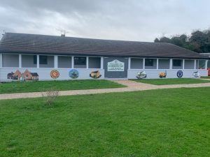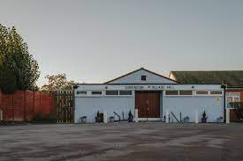

The Parish Council owns and manages both of these this important community assets.

Day to day organisation of room booking and hirers is the responsibility of a part time Manager, Karren Meggitt. The Parish Clerk supports the Manager and co-ordinates cleaning, maintenance and other necessary services.

This is overseen with regular reports to the Village Hall Trustee Committee and the excellent management of hiring the Village Hall by Karren. This has included attracting a much wider range of hirers, with a tighter focus on costs ie. £500 / annum reduction in historic water charges and overseen by good financial management and governance, the Village Hall has become increasing self sufficient financially during 2023.

The parish council is committed to the professional management of the two assets and will ensure full compliance with audit & governance processes going forward, monitor and secure finances with sound and transparent financial reporting, organise annual safety checks ie. fire, electrical, etc and have a maintenance programme for each building.

The parish council will also seek to continue the ongoing renew / refresh / update of the charitable status of the Village Hall in 2024.

The Council will continue to review and when necessary implement improvements to the Village Hall & Pavilion booking & payment service provision via the website.

**Our Commitment:**

To own and operate the Village Hall and Pavilion professionally, with access to all, providing a safe and comfortable environment within the limitations of the current buildings and facilities.

**8.** **Cubbington** **Village Hall**

The Parish Council will continue to manage the Village Hall effectively and increasing look to provide a more cost / benefit business focus and forecasting regarding its day to day operations, for the benefit of all hirers and parishioners.

Extract for the Cubbington Neighbourhood Development Plan

***The current hall is old, inefficient and ill fitted to present needs, originally built in the 1950s as a temporary facility. The Council would like to replace this with a new energy efficient building suitable for multiple purposes and hire which is more suitable and fit for purpose for a population of almost 4000 residents*.**

The Parish Council on behalf of all residents has an aspiration to provide a modern, environmentally, cost-effective Village Hall with the capability to provide facilities for all ages with modern technology that is financially sustainable going forward, with no drain on the council precept. This aspiration must be tempered with the financial reality of how to fund such an improvement or to consider another range of options.

In late 2022 the parish council commissioned architects to provide a scheme in sketch format to test this concept. Complications with the legal and governance situation with the village hall, has meant that this has not been progressed, this work is ongoing.

In reality, moving to outline planning would be dependent in the current economic climate and the likelihood of funding being available therefore, other options will be actively considered.

Improving the access to the village hall by re-opening the footpath from Broadway will also be considered.

Details of the proof on concept, design / feasibility study is detailed below for information:-

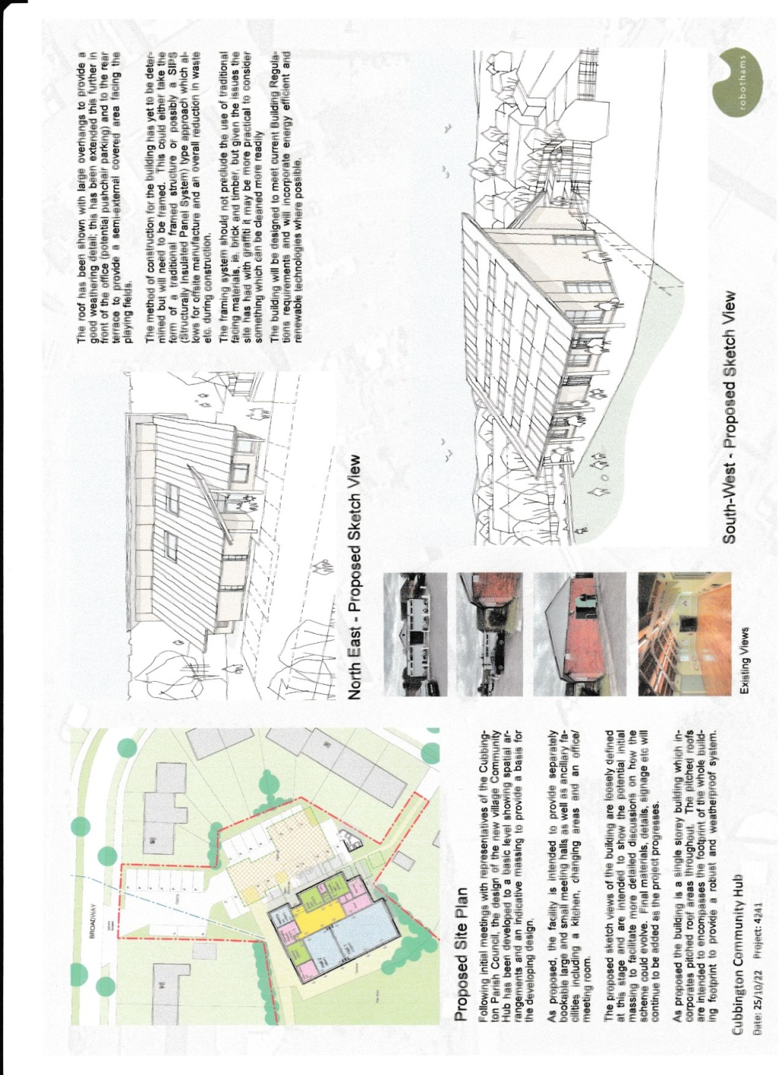

Therefore, going forward into 2024-25, the Parish Council will again consider other options with the guiding principles to establish:-

* A multifunction village hall that can have simultaneous bookings as this is important to ensure that the amenity provides both cost effective hire and is financially self sufficient going forward.
* Any improvements to have no impact on the precept unless residents actively vote for this funding route / option.
* To improve access and ‘street appeal’ to the village hall
* To improve the internal layout and usability ie. Reception area, glass views over park area, improved access to kitchen area, toilets, etc for every hirer of a room
* To provide a more cost effective energy / environmental solution ie. solar panels, battery storage, improved insulation, exterior cladding, etc
* Evaluate the re-opening of the footpath from Broadway to VH
* Removal of some grass areas – hardcore surface to keep tidy, outdoor seating

The Parish Council intend to review all the above options 2024-25 and provide a cost driven plan for each potential option, which will then be subject to grants or other finance provisions and availability going forward.

**Our Commitment:**

To maintain and promote improvements to the Village Hall, that will serve the existing and future population of Cubbington, creating both an environmentally, cost-effective and sustainable community asset.

**9. The Cliff Cleaver Pavilion**

The ‘Pavilion’ is managed and maintained by a Committee appointed by the Parish Council which includes several parish councillors including the Chair Cllr MDanial Meggitt and volunteers from the within the parish.

This Committee should also be recognised as being pivotal in organising community events such as the summer Fun Days and the Christmas Lights and social events.

During 2023 significant upgrades have been made to the building including removing an internal the wall more rentable, provision of a new kitchen, hot water system, WiFi, alarm and non slip surfacing to the ramp. Together with the most recent contribution to the community, the start up of a Cubbington Youth Club, this has been a team effort by the Committee but particular credit must go to Cllrs Ian Hodges, Daniel Meggitt and Esther McCarthy.

.

The Pavilion has a separate business plan and comprehensive Action Plan with the content based on our understanding of the community’s needs, gathered from our day-to-day discussions, involvement with residents and the surveys conducted as part of the Cubbington Neighbourhood Development Plan.

This Business Plan is a statement of intent but as always will have due regard to budget constraints, new legislation or changes in policies, such as Health & Safety. Any changes will, however, be communicated and reflected in an updated Plan.

The Cliff Cleaver Pavilion Business Plan will be available on the Parish Council website.

**Our Commitment:**

To maintain and promote improvements to the Cliff Cleaver Pavilion, creating an environmentally cost-effective community asset, within the predicted lifespan of the building.

**10. Parish Councillor Engagement – internal and external**

The Parish Council recognise that they must always move forward in attempting new ways to operate as a team and to communicate more effectively with key stakeholders, parishioners and other third parties. We will therefore consider these areas:-

* Holding informal quarterly meetings to primarily focus on the Business Plan progress.
* Effectively maintain existing play equipment to safe & good standard, promote new equipment (*new junior football goalposts April 2024 installed*) & facilities (in the right place), climbing wall, padel court or other initiatives, actively seek grants – promote activities.
* Promote the construction and operation of a new Hobby Centre adjacent to the Pavilion.
* Consider the diversity within the Parish Council, consider succession planning, and consider the rotation of key roles amongst all parish councillors.
* Consider the option of monthly surgeries to advise residents on how to best raise issues with the Parish Council, WDC, WCC & Utilities, etc.
* Utilities – maintain the good relations built in 2023.
* Public transport - work with transport providers to support the delivery of an effective, relevant and cost effective public transport offering which may include better monitoring of usage & viability of existing services, promote the installation of electronic bus tables at covered stops, on-demand services, cleaner weather resistant shelters that promote a more sustainable and reliable service
* Keeping the Parish Tidy - effective use of third-party services ie. Payback team, provide work schedule, instruct, monitor.
* Signage – Village Hall & Pavilion look to improve sign posting from primary roads – particularly Pavilion.
* Support to Local Businesses with the promotion of improved car parking (Kelvin Road shops), to avoid pavement parking, funding / planning now obtained via Cllr Sarah Stimpson WCC.
* A suggested plan to improve parking at the Queen Street shops will be investigated and progressed again subject to WCC approval and funding.
* Various pavement renewal works have been carried out in 2023 but other issues including the provision of pavement crossovers in Broadway have faltered due to a lack of response. A resolution is to be pursued

**10. The Parish Clerk**

The role of the parish clerk is one that has increased considerably. The current role is effectively the Chief Executive Officer or business manager of the council.

The role encompasses not only the original purpose to taking notes, arranging meetings and keeping records but also extends to be the legal and financial advisor, publicity officer, organiser, liaison officer for residents and outside agencies etc.

The current clerk, Jane Chatterton, carries out the role on a part-time basis and is also clerk to other local parishes in Coventry and Warwickshire. This joint employment benefits each of the parishes considerably since the experience gathered by one council is shared with the others and this can often lead to cost savings.

It is recognised and valued that Jane goes over and above her paid role too ensure that the progress for the council takes place.

The Parish Council ensures the Clerk maintains her Continual Professional Development points.

The Clerk holds the CILCA qualification.

***Appendix A***

See below the review of the 2024-25 Business Plan, including the completed and agreed carryover actions from 2023-24.







