Cubbington Parish Council
Minutes of the Parish Council Meeting held at 7:00pm 28th March 2024
the meeting was held at the Village Hall

Present:
Councillor Ian Hodges (Chairman) Councillor Gary Willoughby
Councillor David Saul (Vice Chairman) Councillor Daniel Meggitt
Councillor Colin Marrow Councillor Martin Key
Councillor Esther McCarthy Councillor Paul Watkins

Warwick District Councillors: Councillor Josh Payne

Warwickshire County Council: 0

Members of the public: 2

In Attendance: Jane Chatterton, Clerk & RFO

The Chairman welcomed everyone to the meeting. Councillor Hodges was in the Chair.

727. Apologies
Apologies for absence were received from Parish Councillors; Smith, Val and John Roberts and WDC Councillors; Russell, Boad, Kohler. WCC Councillors; Boad and Redford.

- Minutes of the last meeting
The minutes of the Parish Council meeting held on 22nd February 2024 were received and discussed.

RESOLVED THAT the minutes of the meeting held on 22nd February 2024 were approved.

- Matters arising
There were no matters arising.

- Declarations of Interest:
Declarations of Interest were received from:
Councillor David Saul - Pavilion Committee & VHTC
Councillor Ian Hodges - VHTC
Councillor Gary Willoughby - VHTC
Councillor Mrs McCarthy - Pavilion Committee

- Public Participation
The Chairman moved item 10.9 Bus service - to allow for resident input.

Bus service
Councillor Key updated that the service that serves the Village is not reliable. Due to the irregular service people are having to leave much earlier than needed to ensure that they can get to their appointments. There is an increase in residents using the buses for various reasons. Currently if you want to visit the retail park you have to get a bus to the Parade in Leamington and then change service. With more shops moving to the retail park a direct service is now needed.

Residents have reported that they are having to get a taxis, which is expensive.

It was noted that more people are waiting for the buses in the morning and they are predominantly the elderly population of the Parish. Councillor Saul added that the bus service is the link to Leamington and its amenities.

Councillor Josh Payne updated that he met with Stagecoach who had promised to attend a parish council meeting to listen to the issues.

It was suggested that a smaller bus could be put in service to serve residents of Cubbington to access Leamington Town Centre and the retail park and to get people to the doctors etc. This would be a better use of public funds than having an empty double decker bus.

It was also reported that bus passes are not being scanned and therefore the true numbers using the buses are not being recorded correctly.

ACTION:
- Write a letter to Stagecoach to say the Parish Council are unhappy with the service as it is at the minute.
- Put forward a Plan for Stagecoach to consider, that would serve residents.
- Consider access to the Retail Park in the service.
- Copy to the MP for Cubbington and the MP for Leamington & Warwick.
- Copy to be sent to the Courier.
- Ask WCC what conditions were attached to the previous funding eg staff salary and into the bus routes to make it viable.

- Correspondence
The Clerk updated that the unmetered supply to the bus shelter in High Street was provided by SSE. Since the contract started in July 2023 the invoices/bills are inaccurate as the wrong Standing Charge has been applied. The monthly invoices were for more than the agreed annual charge.

Several complaints had been raised with SSE which remained unresolved.

On the suggestion of Councillor Watkins a letter had been sent to the CEO of SSE listing the issues. A response had been received today with the promise to resolve all issues and provide a refund.

ACTION: Clerk to update members when this had been received.

733. Chairman’s Report
Hobby Centre
After working on the plans for the Hobby Centre (Men’s Shed) we have now got pre-planning approval from WDC.

There are a few caveats that have to be completed such as ecology reports and siting of the goal posts but apart from that the WDC would not oppose the plan and have asked us to submit full planning permission.

We have asked a local planning consultant to complete these and they will be submitted in the next few weeks.

Subject to any objections we should be in a position to begin work on this project in a couple of months.

Pavilion New Kitchen
I supervised and oversaw the installation of the new Kitchen in the Pavilion this was completed in a weekend which meant that no bookings had to be cancelled and also we came in well under the price that was quoted by a contractor.

This addition to the Pavilion has added to the booking potential and also increases the facilities and activities for the Youth Club which starts on 12th April.

I have also worked with the Clerk on various matters relating to the parish.

734. Councillors Reports in brief
- Cllr Saul - Community services
Danny Quartermaine – The 26-year-old, who lives in Cubbington, won the IBF European Super Featherweight belt in what was his 100th fight (11th professional) in March. It is Leamington’s greatest professional boxing success since the days of when the legendary Turpin brothers were champions of Britain, the Commonwealth and the world.

ACTION: letter of congratulations to be sent to Danny.

- Cllr Meggitt – Cliff Cleaver Pavilion
New Kitchen – the new kitchen has been installed and is up and running. More services and now available including; a cooker and dishwasher. Councillor McCarthy had managed to get most of the kitchen for free, a £1,000 grant had been received from Cllr Redford.

Thanks to all for a great upgrade.

SSE Electricity supply – the Pavilion were also incurring issues with SSE who had said the bill was £7,500 and they took the funds via direct debit. Councillor Meggitt had met with the Contractor on site. A formal complaint had been sent.

ACTION: agenda item for May’s meeting.

Business Plan for the Pavilion – the Business Plan for the Pavilion had been broken down into individual areas and people have been allocated against the tasks to start the work with target dates. This will add to the viability of the Pavilion.

Acorn Easter Egg hunt – the Charity Acorn would be holding an Easter egg hunt on the Recreation Ground on Sunday 30th March for children and adults.

Youth Club – donations for the Youth Club included an air hockey table, pool table, snacks and drinks. 13 children have taken the forms to join. The Clerk has organised the DBS checks for Youth Worker. A meeting would take place to put together a plan for activities including asking the children what they would like to do.

The Youth Club would open on the 12th April, 6:30pm to 8:30pm at the Pavilion. People have come forward to offer various activities including cricket, football, arts and crafts.

Thank you to Councillor McCarthy for all her hard work.

735. District and County Councillors Reports for information
Councillor Payne (WDC)
No mow May – WDC had updated that they were going to allow further areas to overgrow.
There were no plans being shared about what happens when the grass is cut.
ACTION: provide input about the cutting process.

Severn Trent – has spoken to Severn Trent about communication complaints. The contact process has been lacking.

736. Highways
736.1 Review Outstanding Highways Issues
- Welcome to Cubbington Sign replacement - Kenilworth Road (Cllr S Boad)
ACTION: Councillor Mrs Boad had been in contact with Ryan Machin who had agreed to replace the sign. Chase an update.

736.2 VAS Sign Rugby Road
ACTION: Chase a response.

736.3 Rugby Road Crossing
This was in hand via Councillor Redford.

736.4 Path – Rugby Road to Offchurch Lane
ACTION: chase a response.

736.5 20 mph speed limits
Councillor Wallace Redford (WCC) – update provided
20mph flashing lights – to operate at school arrival and departure times for both Village Primary Schools were being pursued.

736.6 Bus shelter in Queen Street
ACTION: chase a response.

736.7 Bus stop sign Rugby Road
ACTION: chase a response.

736.8 Lack of Response from Localities Officer
ACTION: Formal complaint to be sent to Scott Tomkins listing all the outstanding issues.

736.9 Bus service
Discussed under Public Participation

737. Police
Councillor Saul had attended the Police Liaise meeting.

Community Wardens
Community wardens provide a high visibility presence across the district, with a focus on hotspot areas for anti-social behaviour (ASB). The wardens main responsibilities include:
- Intelligence led patrols in hotspot areas for ASB and neighbourhood crime.
- Providing support, crime prevention advice and all-round excellent customer service to the community and partner agencies.
- Dealing with incidents of ASB which include education and enforcement of the district's Public Space Protection Orders (PSPOs)
- Working closely with key stakeholders such as Warwickshire Police to ensure that Warwick District continues to be a safe place for all.
- To develop and promote community safety activity in the district, contributing to our strategic priorities and partnerships. Please note, if you wish to report a crime, please contact Warwickshire Police on 101 or 999 in an emergency

Phone: 01926 456010
Email: community.wardens@warwickdc.gov.uk

738. Finance
738.1 payments PAID since the last meeting:-
2023-24
DATE |  | REF | DETAILS | EXPENDITURE
21.02.24 | E158 |  | Parish Online Membership | £259.20*
21.02.24 | E159 |  | The Sign Shed new signage | £142.75*
27.02.24 | E160 |  | E McCarthy Youth Club Chairs | £140.00
27.02.24 | E161 |  | Grant Application Tables Happy Days | £200.00
28.03.24 | E162 |  | Mr I Hodges – Ink | £19.45
05.03.24 | E163 |  | Costco Membership | £67.20*
05.03.24 | E164 |  | Mrs L Montgomery Key Holder Fee | £150.00
05.03.24 | E165 |  | Top Source Inv 010326 | £13.81*
05.03.24 | E166 |  | Mr G Willoughby Inv 0066 | £60.00
07.03.24 | E167 |  | J Chatterton DBS Checks Youth Club EMc JLC | £76.56
07.03.24 | E168 |  | npower Christmas lights unmetered supply | £63.08
11.03.24 | E170 |  | N Griffin Pavilion Kitchen Installation | £1,800.00
11.03.24 | E171 |  | Mr I Hodges - Electrical and plumbing Supplies Pavilion | £1,055.24*
14.03.24 | E172 |  | ICO Membership renewal | £35.00
14.03.24 | E173 |  | J Chatterton Clerk Salary March 2024 | DPA
14.03.24 | E174 |  | HMRC Tax & NI Employer & Employee March | DPA
14.03.24 | E175 |  | WCC Clerk Pension Employer & Employee | DPA
14.03.24 | E176 |  | J Chatterton Compost for street Planters | £60.00
14.03.24 | E177 |  | Kirkwells Ltd NHP Invoice 1294 | £3,240.00*
20.03.24 | E178 |  | Cliff Clever Pavilion - Youth Club room hire FROM GRANT | £1,170.00
20.03.24 | E179 |  | Mr I Hodges - Pavilion Ramp repair | £703.39*
20.03.24 | E180 |  | Happy Days - Staffing for Youth Workers FROM GRANT | £3,510.00
20.03.24 | E181 |  | J Chatterton - Clerk expenses March | £100.99*
20.03.24 | E182 |  | J Chatterton DBS Checks Youth Club IH MK | £22.56
*including VAT

RESOLVED THAT the payments be approved.

738.2 Village Hall Accounts 2022
VHTC Chairman (Cllr Willoughby) updated that the Village Hall accounts for January 2022 to December 2022 had been produced and Audited by the VH Accountants.

This has been a lengthy and difficult process. As reported previously the Parish Council and Village Hall Trust Committee had to take legal action against the previous Committee to obtain the Village Hall Bank Account funds. This process took 18 months.

The 2022 figures have been previously circulated to all council members and comments sort. The headline is that 2022 has seen a significantly improved income v expenditure performance compared to the previous year.

Work has now started on the 2023 accounts.

The figures for comparison are below:

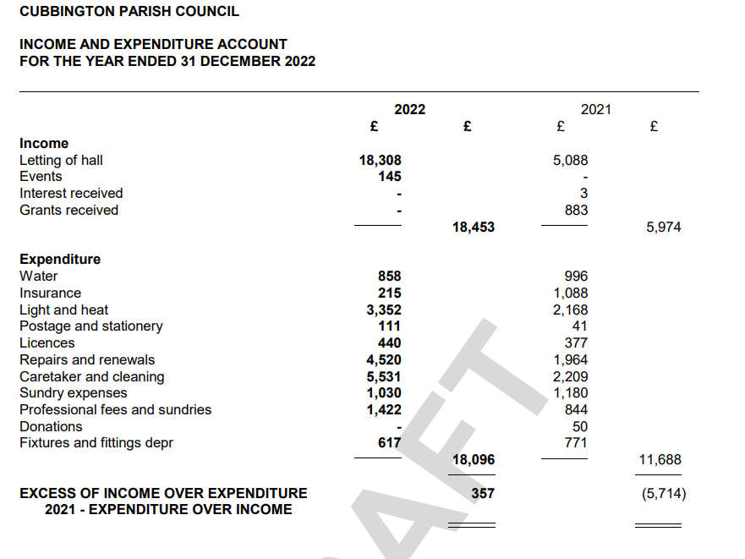

739. Governance
The following policies had been reviewed.

- Asset Register 2023-24
- CPC Internal Financial Control March 2024 (no updates)
- CPC Risk Assessment March 2024 (no updates)

RESOLVED THAT the policies be approved.

740. CPC Business Plan
Councillor Willoughby updated that the CPC Business Plan had a review date set this month. This would include a recognition and celebration of achievements 2023-24 that goes on the record and an updated, revised and published 2024-25 Business Plan by end May 2024.

Councillor Willoughby would draft the document by end April and circulate ahead of May’s Parish Council meeting with a view to approval by end May.

Councillors were asked to review the current Plan and submit their comments on delivered actions, particularly on actions that they had personally owned or had a strong view on, plus any new ideas/suggestions for 2024-25 going forward. The deadline for this was Friday 12th April.

741. Quarterly newsletter
ACTION: revisit the idea. It was agreed that Councillor Watkins would lead.

742. Planning Matters
Nothing to discuss.

743. Project Men’s Shed
As reported under the Chairman’s report.

744. Neighbourhood Plan
Councillor Watkins updated that all the discussion notes had been received and the Statutory Consultees had been consulted. Kirkwells were putting the final plan together. The next stage would be Inspection and then referendum.

745. HS2 Update
Nothing further to discuss.

746. Councillor’s reports and items for future Agenda:
Highways – Church Terrace – pothole - Has been reported. Marked it up but haven’t done anything about it. Not treating it as an emergency.
ACTION: report the pothole and Fix My Street.

Fun Day – a meeting was called to organise the Fun Day 2024 but only 3 people turned up. Need more volunteers to help out and put forward ideas.

747. Date of the Next Meeting
The date of the next meeting was confirmed as Thursday 23rd May 2024 following the Annual Parish Council Meeting.

Meeting closed at 8:00pm

